3. Develop a code to upload the water tank level and light intensity values to the IBM IoT platform and visualize them in the web application.

CODE:

import wiotp.sdk.device

import time

import random

myConfig = {

"identity": {

"orgId": "glif1g",

"typeId": "sarahdevice",

"deviceId":"060801"

},

"auth": {

"token": "06082001"

}

}

def myCommandCallback(cmd):

print("Message received from IBM IoT Platform: %s" % cmd.data['command'])

m=cmd.data['command']

client = wiotp.sdk.device.DeviceClient(config=myConfig, logHandlers=None)

client.connect()

while True:

tanklev=random.randint(0,200)

liv=random.randint(50,200)

myData={'watertanklevel':tanklev, 'lightintensityvalues':liv}

client.publishEvent(eventId="status", msgFormat="json", data=myData, qos=0, onPublish=None)

print("Published data Successfully: %s", myData)

client.commandCallback = myCommandCallback

time.sleep(3)

client.disconnect()

Node red:

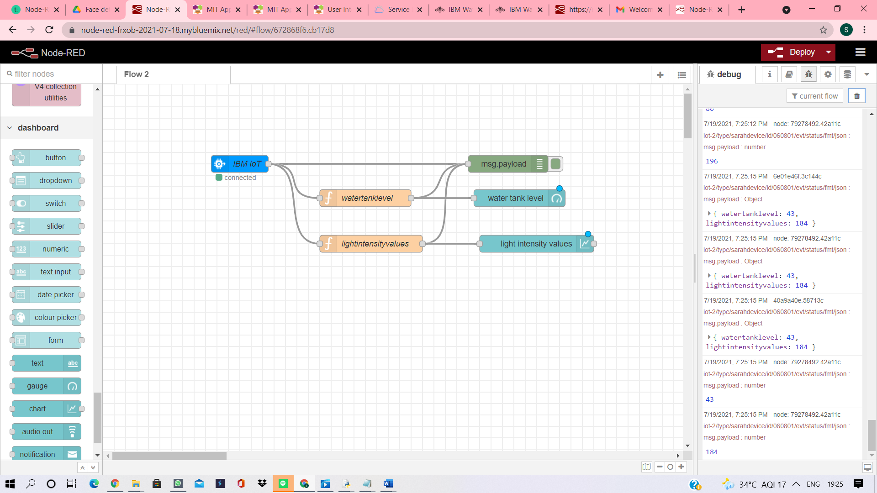

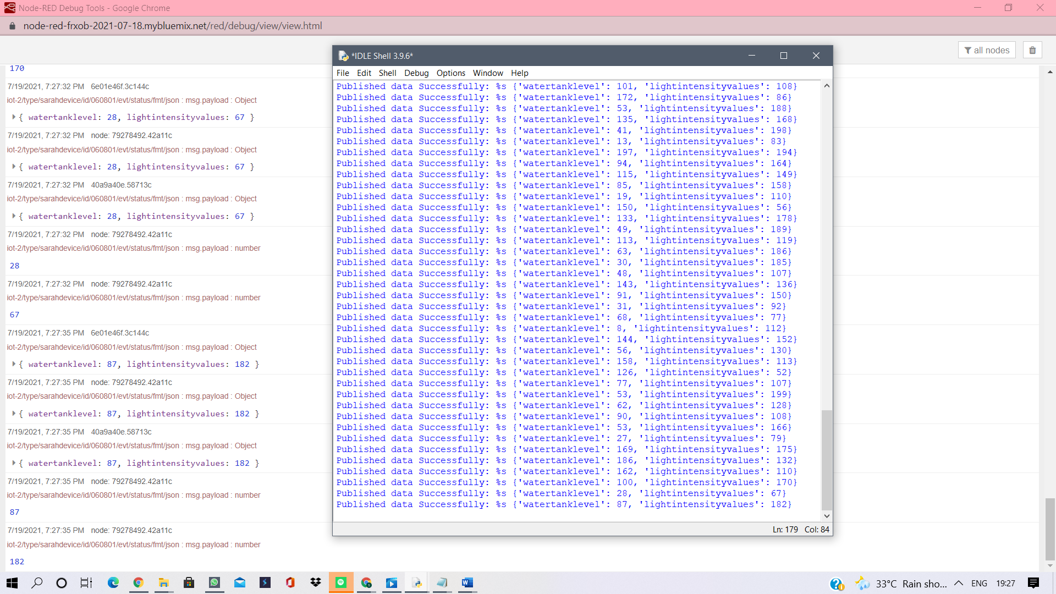

SIMULATION:

